**“We consider a 3D CAD catalog as a step towards Industry 4.0“**

Native CAD data from CADENAS product catalog as innovation at Pepperl+Fuchs

**Augsburg, Germany, 13th June 2016.** The new electronic Pepperl+Fuchs catalog, based on eCATALOGsolutions technology, is online. The company was founded in 1945 and today it is a leading manufacturer of industrial sensors operating inductive, capacitive, ultrasonic and photoelectric as well as components and technologies for process automation.

At <http://pepperl-fuchs.partcommunity.com> engineers have access to currently 5800 CAD components from Pepperl+Fuchs. Also 10 configurable rotary encoder families in over 400, 000 variations are possible. Currently the company’s CAD catalog is available bilingual in the corporate design of Pepperl+Fuchs.

Additionally, a wide range of search features is available to engineers and purchasers: The 2D sketch search as well as the geometric similarity search GEOsearch and the high-performance full-text search are useful and quick helpers for this purpose. Moreover, customers can easily obtain further information from Pepperl+Fuchs with an RFP and via the 3D PDF data sheet.

**The initial situation**

In the course of digitization, heading towards Industry 4.0, Pepperl+Fuchs now makes its CAD data available online. In doing so the company had special requirements regarding the electronic product catalog: On the one hand, a form variety of native data formats had to be ensured. Many different output formats for print, internet, price lists or catalogs should be generated from one single data source. On the other hand, a precise and detailled display of CAD models is necessary for the customers. Also a preview of the product and integrating it directly into the respective CAD program had to be made possible. Moreover, it was important to Pepperl+Fuchs to offer a central product portal.

**Import existing STEP and BMEcat data into the 3D CAD product catalog**

Already existing data and models were able to be imported as STEP and BMEcat data, so that no costly new installations were necessary. Several product families were newly created so that these are configurable. Soon Pepperl+Fuchs products are going to be extended with 10 rotary encoder families which can also be completely modeled and configured.

**Fruitful cooperation beyond the project**

The cooperation between Pepperl+Fuchs and CADENAS was so extremly good, that Markus Bamberg held a best practice presentation about it at this year’s Industry Forum in the WWK Arena. He especially praised the company, as the project management and the holistic advice helped to realize the project according to the specific requirements.

Markus Bamberg explained that they chose CADENAS , since the company stands for development and innovation: “ CADENAS is always looking for customer solutions. You never have to be afraid of a standstill when working together with the software developer from Augsburg. That creates trust!“, Bamberg explains. Pepperl+Fuchs puts special emphasis on customer service and with the digital 3D CAD catalog, they hope to extend the reach, generate new leads and develop further technologically – all in all a first step towards Industry 4.0. Additionally, a deep integration of the electronic product catalog is going to take place on the company website.

**Press Images:**

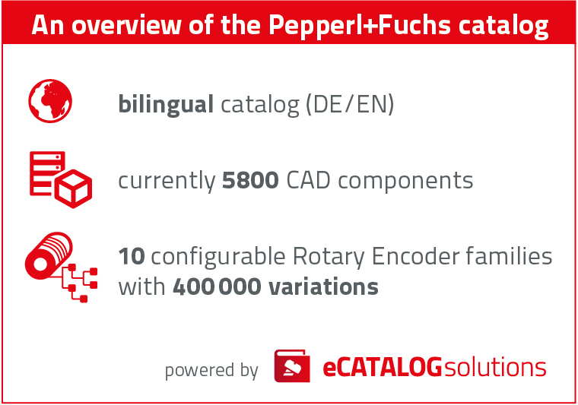

**Caption 1:** Engineers have access to the bilingual catalog and to currently 5800 CAD components from Pepperl+Fuchs.

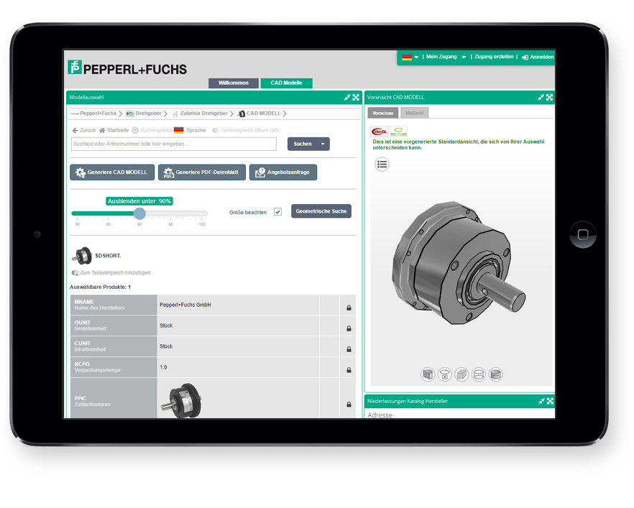

**Caption 2:** The 2D sketch search as well as the geometric similarity search GEOsearch and the high-performance full-text search are useful and quick helpers for this purpose.

This press release and accompanying images are available for download from our website: [www.cadenas.de/press/press-releases](http://www.cadenas.de/press/press-releases)

**About CADENAS**

CADENAS is a leading software developer in the areas of Strategic Parts Management and parts reduction (PARTsolutions), as well as Electronic Product Catalogs (eCATALOGsolutions). With its customized software solutions, the company acts as a link between the component manufacturers with their products and the purchasers.

With its 300 employees at 17 international subsidiaries, the name CADENAS (Hispanic: process chains) has been standing for success, creativity, support and process optimization since 1992.

For further information, please visit: www.cadenas.de/en